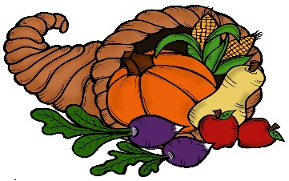 **NOVEMBER 2019**

**MEAL PLAN**

Mon Tues Wed Thurs Fri Sat Sun

|  |  |  |  |  |  |  |
| --- | --- | --- | --- | --- | --- | --- |
|  |  |  |  | **Pizza** | **Penne Vodka with Chicken**  **Salad** | **Meatloaf**  **Mashed Potatoes** |
| **Crockpot Chicken & Stuffing** | **Chicken Fajitas** | **Crockpot Beef Stew** | **Chicken Lo Mein** | **Crockpot Apricot Chicken** | **Beef Fried Rice** | **Creamy Pasta** |
| **Tortellini Soup**  **Garlic Bread** | **Tacos** | **Parmesan Crusted Porkchops**  **Rice**  **Green Beans** | **Spaghetti & Meatballs**  **Garlic Bread**  **Salad** | **Pizza**  **Salad** | **Grilled Cheese**  **Tomato Soup** | **Crockpot Beef Stew**  **French Bread** |
| **Crockpot Chili & Loaded Baked Potatoes** | **Chicken Quesadillas** | **Chicken Picatta**  **Veggies**  **Rice** | **Porkchops**  **Rice & Beans** | **Chicken Parmesan Meatballs** | **BBQ Pulled Pork Sandwiches**  **Coleslaw**  **Oven Fries** | **Meatloaf**  **Mashed Potatoes**  **Veggie** |
| **Chicken Parmesan**  **Casserole** | **Chicken Marsala** | **Crockpot Taco Soup** | **Thanksgiving Dinner**  **Turkey**  **Stuffing**  **Mashed Potatoes** | **Thanksgiving Leftovers** | **Pierogies** |  |